Task 1

Create a Django project name ‘studentid_studentname’ for example : BCS2107001_Ahmad

Task 2 : Create a subproject name Enrolment

Task 3 : Add application in installed apps setting.



Task 4 : Create Class based on the table provided.

Task 5 Insert and save data into database.

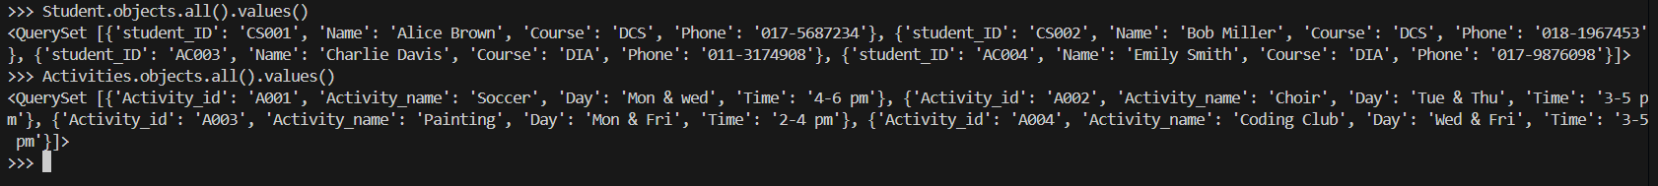Task 6 : Display all tables and its objects data using Visual Studio Code

Task 7 : Add new field Status in table Student and set default value to “Active”

Task 8 : Update status data for student AC003 to ‘inactive’ in table Student

Task 9 : Display student id and enrollment date for all student enrol in activity ‘A004’ using command prompt

Task 10 : Delete Choir from table Activity.

